Week Of: May 4-8
Learning Intentions/critical skills | Resources | Task | Success Criteria: Self-Assessment
 |  | Extension: On Monday you watched me do an experiment with milk, food colouring and dish soap. Did you try it at home? You could experiment with different ingredients. What would happen if you used oil or vinegar instead of soap?
- Reflect on and develop preferences about books and literacy  - Verbalize their preferences and summarize their story  - Verbalize their favourite parts  - Sequence events to retell a familiar story | Your favourite story | Task 1: What is your Favourite Story?  - Choose your favourite story and ask someone in your home to read it to you. Can you learn how to tell this story to someone else by reading the pictures?  - Practice telling others about your story: what is your story about? Why is it your favourite? Do you have a favourite part?  - At our small group google meetings, you will get to share your story with us. I would like you to tell us what your book is about and why it’s your favourite story. You could also show us your favourite part.  Extension: call or video chat with a grandparent, or a friend and read them the story. You can read the pictures to tell the story! | I can independently:  - Talk about and share my favourite story with my teacher and friends
(this is an optional task) | -Coloured paper  -Crayons/pencil  -Scissors  -Glue/tape  -Popsicle stick/straw/stick from backyard  -small photo of your child’s face | Task 2: Mother’s Day (this is an optional task)  - Top Secret – dad’s and kids only  - Hey Dads, This is just a friendly reminder that it’s Mother’s Day on Sunday! Please click here for a suggested craft you could do with your kids | (this is an optional task, but it’s great for fine motor work!)
- Experiences and develops locomotor and non-locomotor skills  - Demonstrates body and space awareness  - Recognizes personal abilities while participating in physical activities  - Records experience and enhances ongoing fine motor development  - Uses symbols to record directions  - Uses phonetic (relationship between letters and sounds) understanding to engage in printing experiences | Space and items in your home or yard  Paper  Pencil  colours | Task 3: Get Moving!  - Part 1: Create an obstacle course in your home or backyard! Your course should include something to move through, over, under, around and in between. You could include different ways of moving, balances or actions.  - Part 2: Draw a map of our course. You could use different types of arrows to show how you moved through your course. After you draw your map, label the items that were in your course. Please send me a photo of our map! I will share them on our website | (part 1) I can independently:  - Understand propositional words (over/under/  through/in between)  - Explore various ways of moving my body
(part 2) I can independently:
- Use appropriate pencil grip and pressure to draw
shapes to draw a picture
- Label items in my picture with beginning sounds, or use inventive spelling*

- Uses phonics and structural analysis: makes connections between letters and sounds  - participates in fine motor development tasks | -Downloaded code  -Paper and pencil | Task 4: Solve the Spring Time Riddle!  - The pictures are your letter clues. | I can independently:  - Hear the beginning sounds of familiar words  - Form recognizable letters
- explores and investigates objects and events in the environment  - recognizes changes in weather and some ways people and animals adapt to the seasons  - recognizes familiar animals and their characteristics and surroundings  - uses literacy skills to record observations  - uses numeracy skills to analyze observations | -calendar  -pencil and crayons | Task 5: Spring Calendar (con’t from previous week)  - This is an ongoing project posted last week. If you missed it last week, please click here to review this task.  - How many signs did you notice? Did you see more or less signs of spring this week?  - Send in a photo or drawing of your favourite sign of spring. Parents, if you like, your child can take these photos. We could have some blooming photographers! I will share these photos on our website. | I can independently:  - Make observations about my environment and surrounding  - Record my observations with pictures and words  - Count and Compare using the words: more/less/equal
- Inventive spelling is when children independently pull apart the sounds of words and record the letters they hear. They may record the beginning sound, or the beginning and ending sound, or include the middle sounds. As children learn more letters, sounds, and phonetic rules, their inventive spelling will become more accurate.

How does a bee brush its hair?

With its ___________!

 |  | 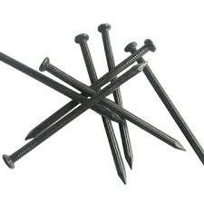 | 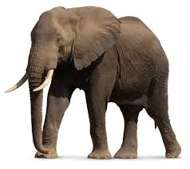 | 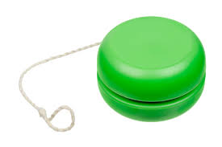 | 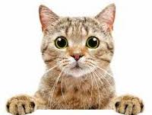 |  | 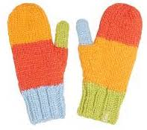 | 