Week Of: April 13-17
Learning Intentions | Resources | Task | Assessment (I Can)
-participates in a shared reading experience  -sequences a visual story  -retells a familiar story using visual prompts  -hears and generates rhyming words  -continues to develop understanding of print (directionality, tracking) | Link to the worksheet  Scissors  Glue  colours | - Print the Humpty Dumpty worksheet. The pictures are all mixed up! You will need to cut them out and glue them in the right order.  - Practice reading the poem with an adult. Watch how they point to the words when they read one line at a time. Now you try!  - Talk about the rhyming words in the poem. Can you think of other words that rhyme with ‘wall’ and ‘men’ | I Can Independently:  - Sequence pictures to tell a story  - Use pictures to retell a familiar story  - Engage in literacy experiences by beginning to track print  - Identify and create rhyming words
-explores the attributes of 3D shapes | Egg  3D shapes in home | - Practice reading your Humpty Dumpty Poem  - Humpty Dumpty is an egg! No wonder he couldn’t sit on the wall, he roles! If Humpty Dumpty was a different shape, would he role?  - Find an example of the following 3D shapes in your home (parents: I have not yet talked about 3D shapes in our class. This will be new learning for your children)  - A sphere  - A cube  - A cone  - A cylinder  - A pyramid  What would be the best shape for Humpty? Why?  - Just for fun, draw a Humpty Dumpty face on an egg and watch how it roles and wobbles! | I Can Independently:  - Compare 3D shapes to real items (a cube is like a ___)  - Experiment and talk about the attributes of 2D and 3D shapes
-engages in ‘scientific process’ (predicting, testing and analyzing)  -makes observations and makes appropriate adjustments | Hard boiled egg  Building materials | - Practice reading your Humpty Dumpty Poem  - Hard Boil an Egg  - Collect thin items in your home that you can stack or build with (lego, books, etc.)  - Start by building a very short tower. Put your egg on the top and let it gently role off. Did your egg crack?  - Predict how tall your tower will get before your egg cracks.  - Build your tower just a little bit taller. Let your egg gently role off. Did your egg crack?  - See how tall you can build your tower before your egg cracks!  - How tall did your tower get before your egg cracked?  - Don’t let a good egg go to waste! Eat your egg, make it into an egg salad sandwich, or a Deviled Egg snack | I Can Independently:  - Use appropriate materials to do an experiment  - Make observations and adjust my structure  - Use nonstandard units of measurement to measure the height of my structure
-engages in a creative process  -development of fine motor skills and appropriate use of tools  -engages in a process that taps into spatial awareness development | Paper (white and a coloured paper)  Scissors  colours | - Practice reading your poem. This time, pretend that you are a teacher and your stuffies are your students. Teach your students how to read your poem!  - Draw an egg shape on a white paper and cut it out. When your cutting, make sure you remember our cutting rules: the scissors point away from you, your thumb goes up to the ceiling and your fingers go down to the floor, your elbows stay tucked in, and you have a cutting hand and a steering hand.  - Now pretend that your egg got broken! Cut your egg into broken pieces.  - Now ‘reconstruct’ your broken egg pieces to make a new picture! Feel free to add or glue details to your reconstructed egg. I have provided you with a photo that shows examples to see what other kids have done!  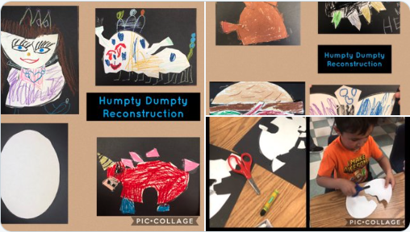  - Take a photo of your art and send it to me! I will share these photo’s on our website. | I Can Independently:  - Use tools (pencil, crayons, scissors, glue) with age appropriate fine motor skills  - Use spatial awareness and explore creativity
-engages in a shared literacy experience  -develops comprehension skills (making predictions; making personal connections to the characters)  -emotional intelligence (recognizing and empathizing with the emotions of others and self)  -recognizes a personal connection between a story and personal experiences  -through picture and text, responds to a prompt, reflects and records own experiences | Adult supervised use of Youtube  Journal or paper  Pencil  colours | - With parent supervision, watch the story After the Fall by Dan Santat (Parents: don’t play the full story yet. You will pause it when Humpty’s airplane gets stuck on the wall)  https://www.youtube.com/watch?v=dUKt1a6I3yw&t=1s  - How did Humpty feel about the wall before he fell off of it? How did he feel about the wall after he fell?  - Pause the story at this page when Humpty’s plane gets stuck on the wall (2:10 minutes into the story)  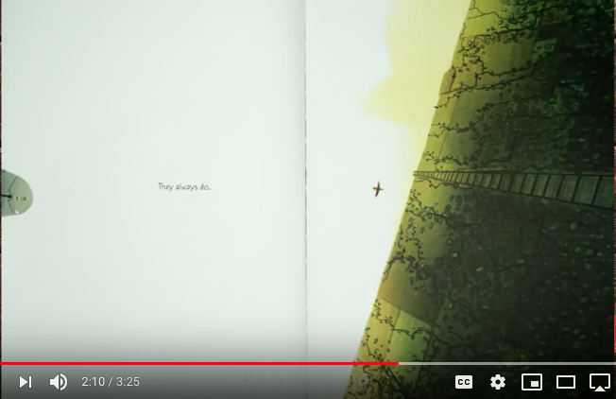  What do you think Humpty is feeling right now? What do you think Humpty is going to do? Play the rest of the story.  - How did Humpty feel when he got to the top of the wall?  - We’ve talked about how there are 2 kinds of nervous feelings: the kind of nervous feeling that keeps you safe and tells you not to do something, and the kind of nervous feeling that you know is safe because you are in a safe place with safe people. Have a conversation with your family about this feeling, and the difference between the 2 kinds of ‘nervous’ feelings.  - In your journal or on a paper, draw a picture of a time that your tried something that made you feel nervous (the safe kind of nervous). Please make sure that your picture also has some letters and words on it. You could label items in your picture, write a title or try a simple sentence! Please remember our journal rules: draw with a pencil first and then colour. When you draw and colour your picture, make sure you include enough detail so that someone else can read your picture.  Extension: Your picture could have 2 parts: one part of when you felt nervous and one part about how you felt after.  - Please take a photo of your response  Extension: make a paper airplane just like Humpty! | I Can Independently:  - Engage in a story read aloud  - Make a reasonable prediction  - Recognize and talk the emotions in others  - Make connections between a story and my own experiences  - Verbally and visually respond to a story and prompt that others can read and respond to

